**Task Description:**

Create a S3 bucket, with no public access and upload files to the bucket & view the logs using cloudwatch for the uploaded files.

Launch two ec2-instances and connect it to a application load balancer, where the output traffic from the server must be an load balancer IP address

Create s3 bucket:

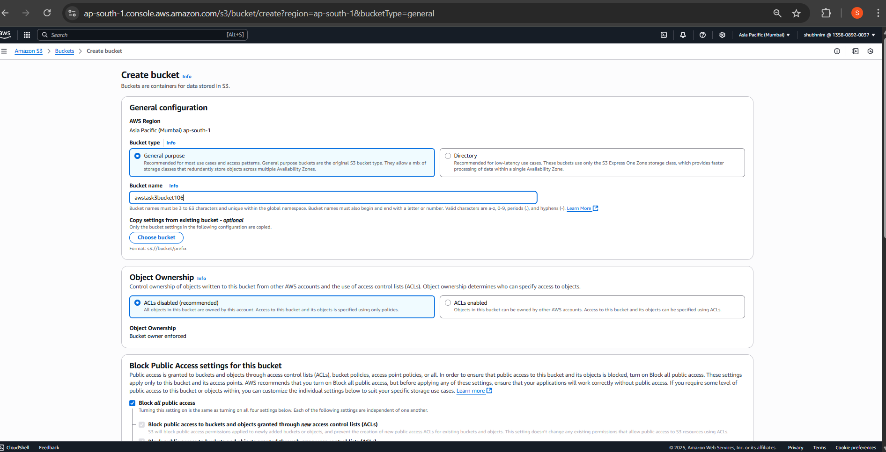

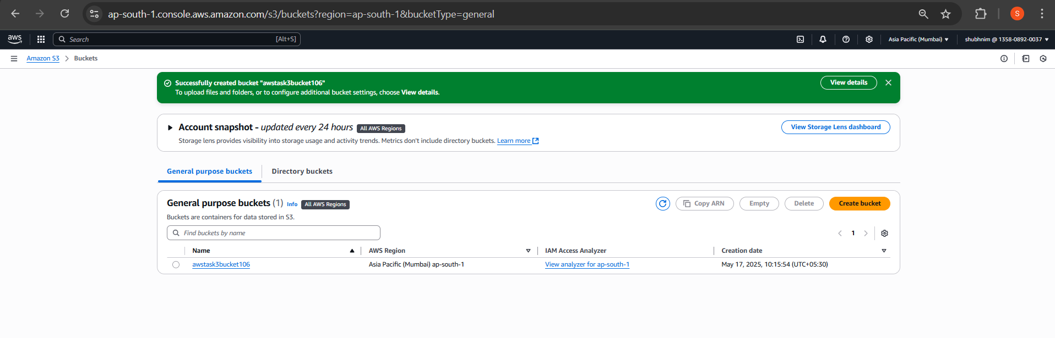

**Upload file:**

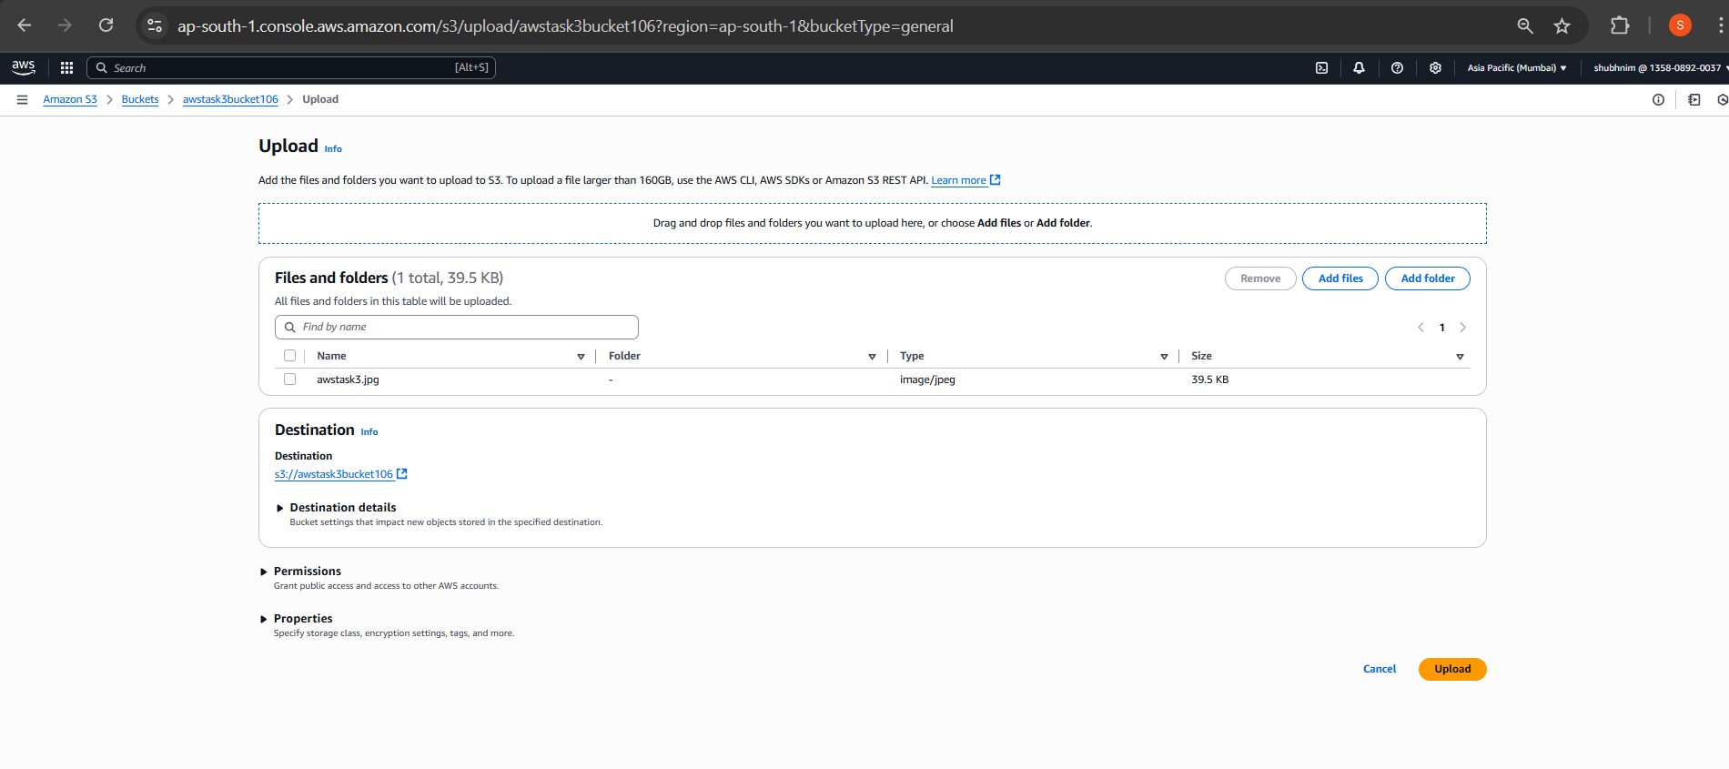

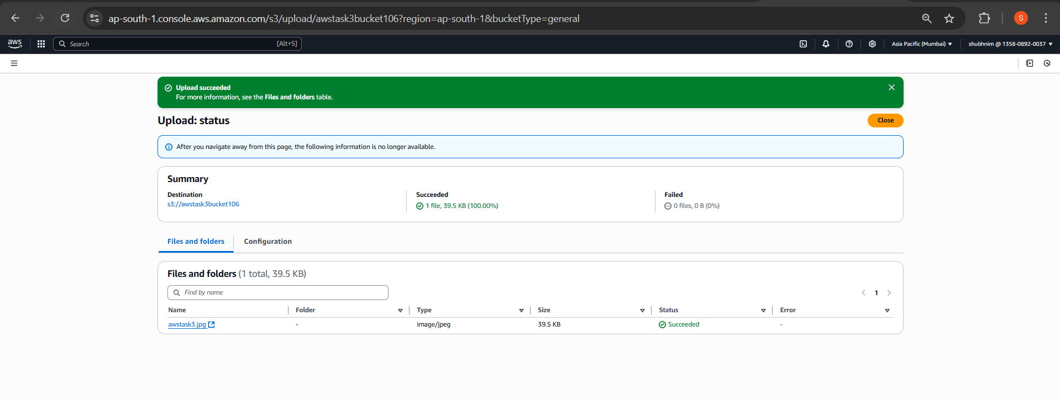

**Enable CloudWatch Logging (S3 Access Logs):**

**Created cloud trail:**

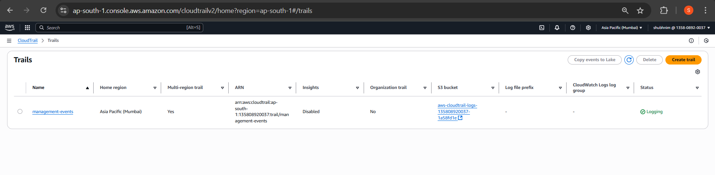

**Enable data event logging for S3:**

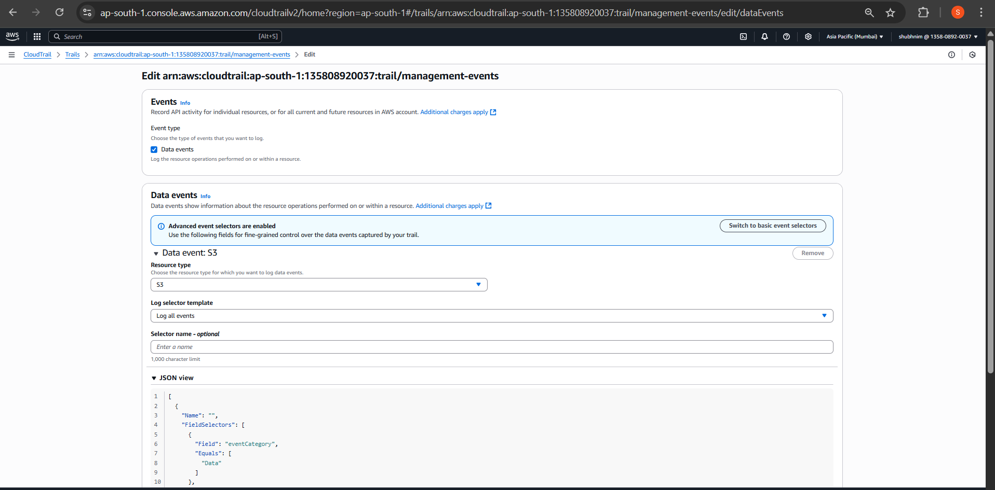

**Send logs to a CloudWatch log group**

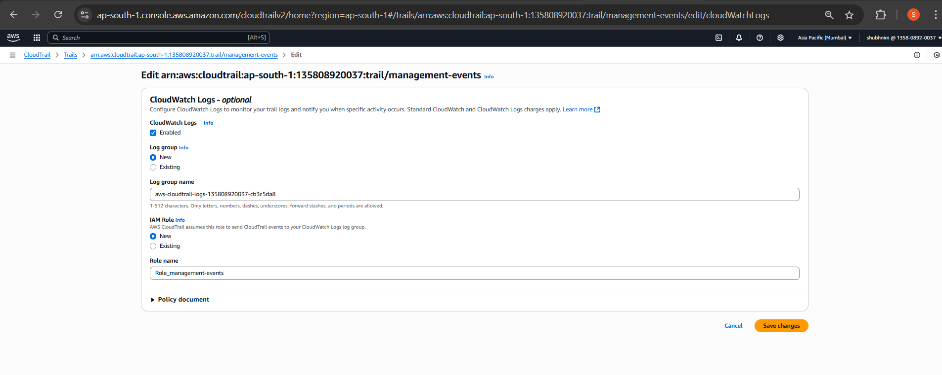

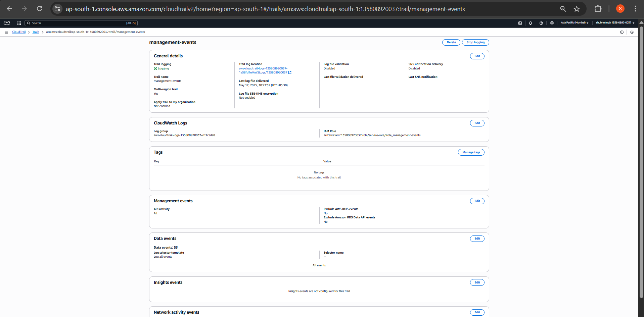

**Cloudwatch is showing PutObject events as logs**

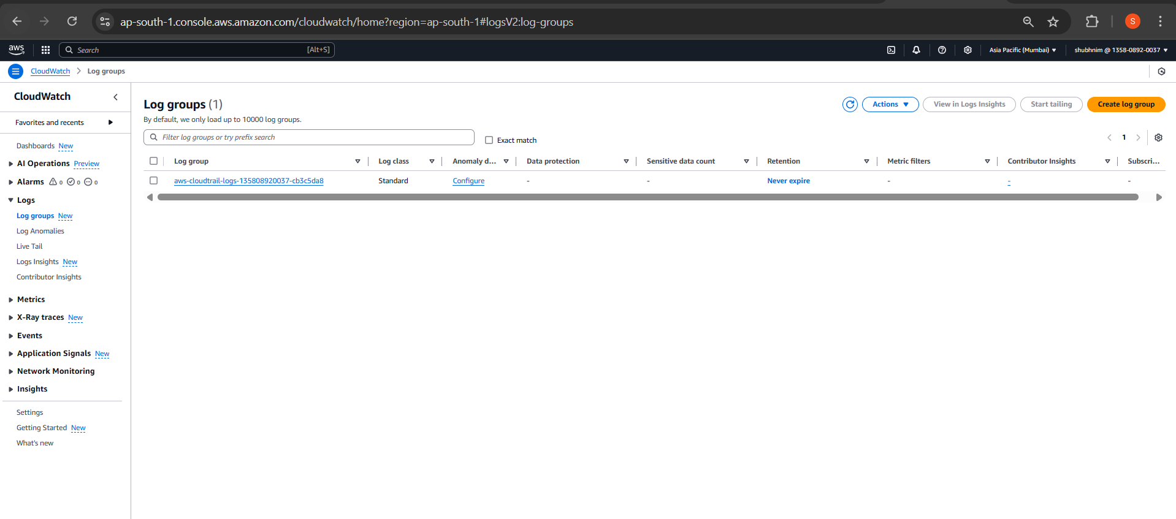

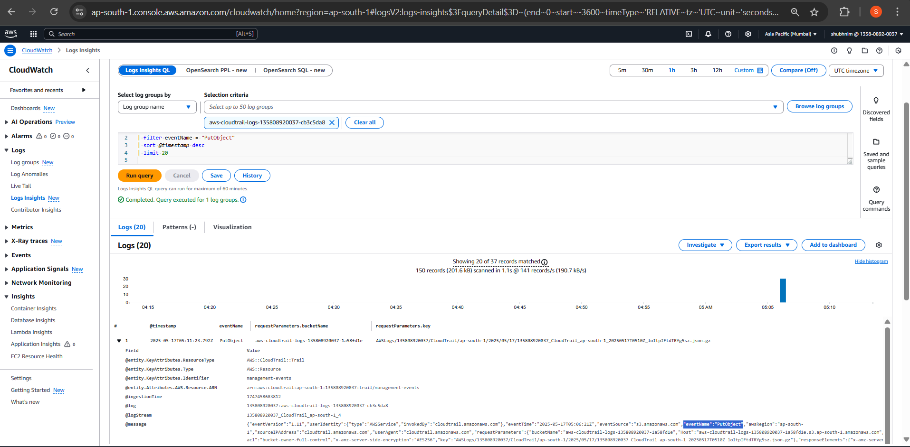

Launch Two EC2 Instances:

EC2-1

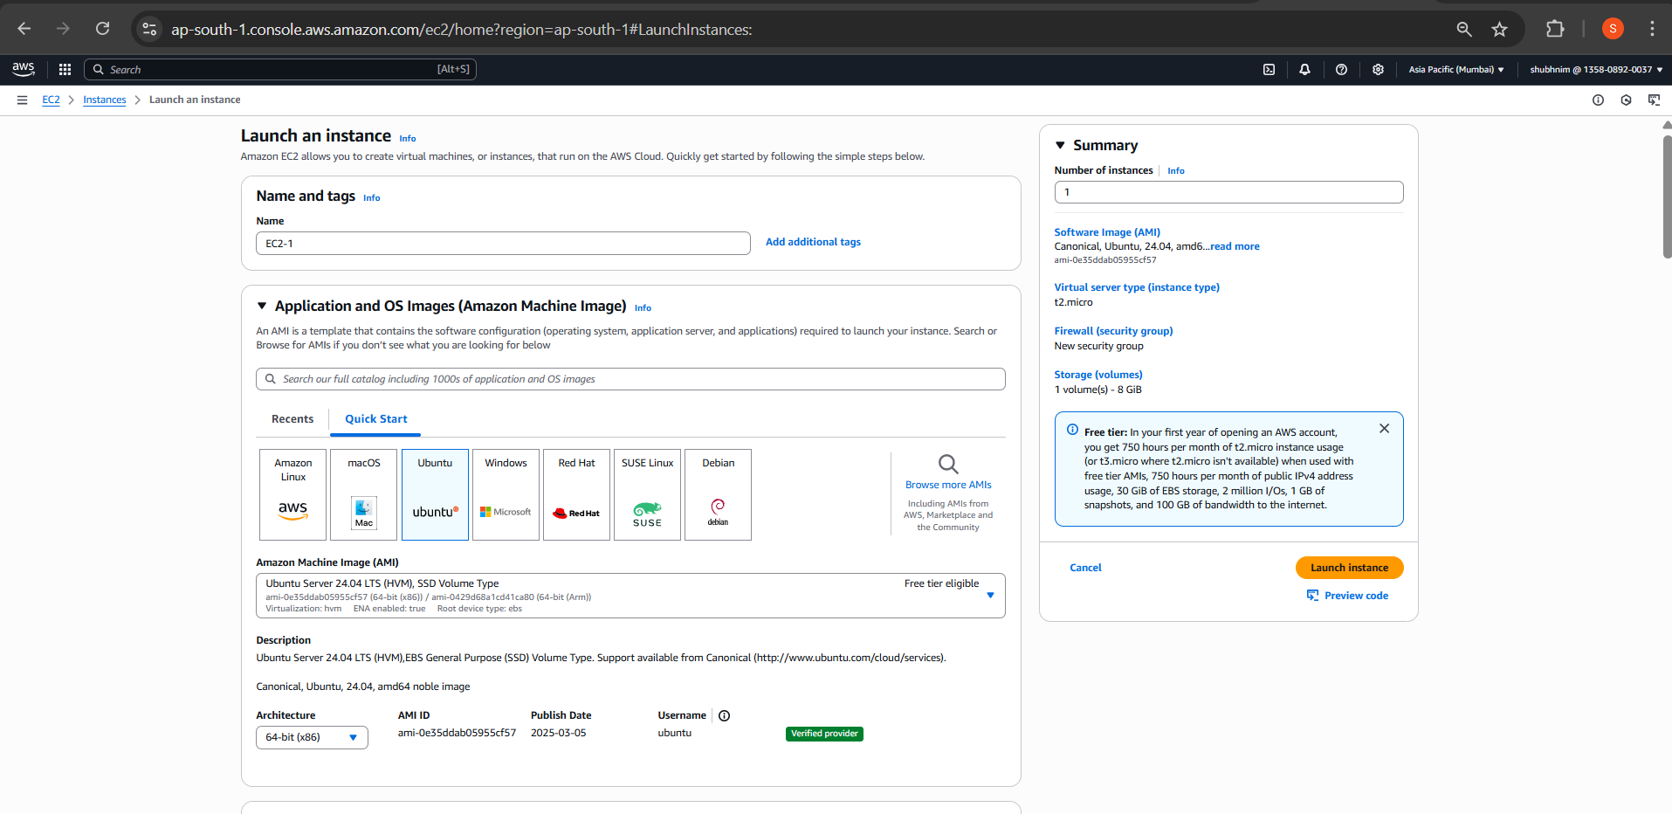

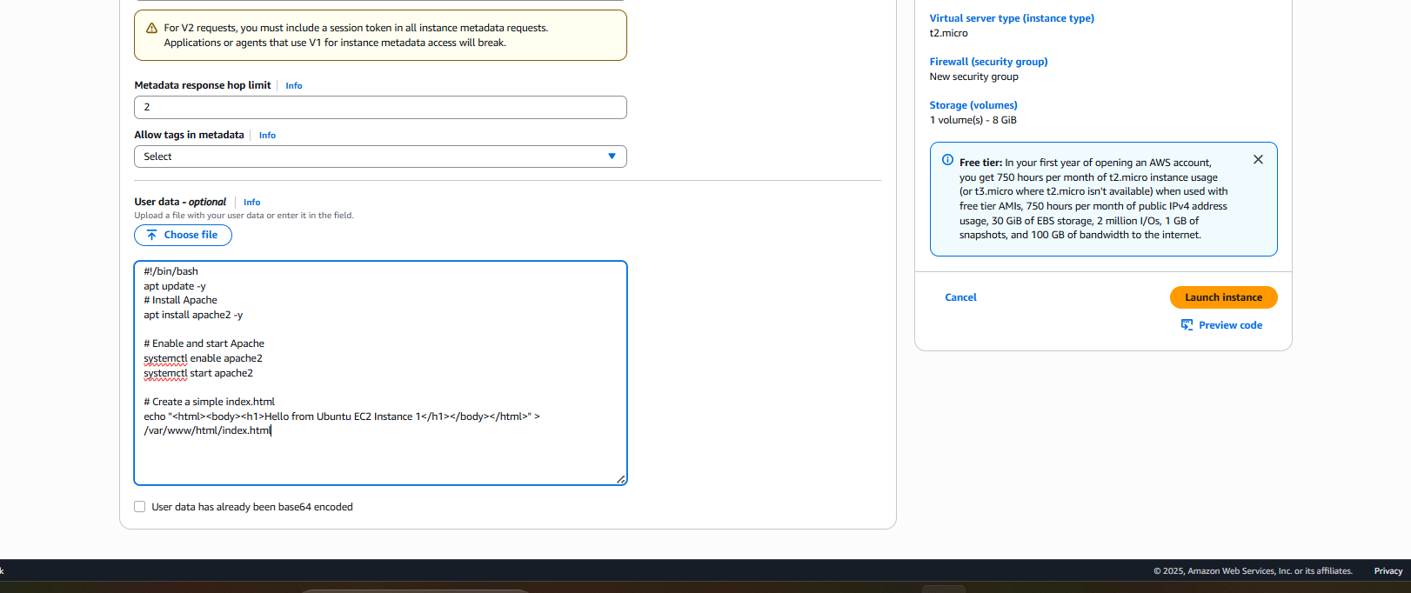

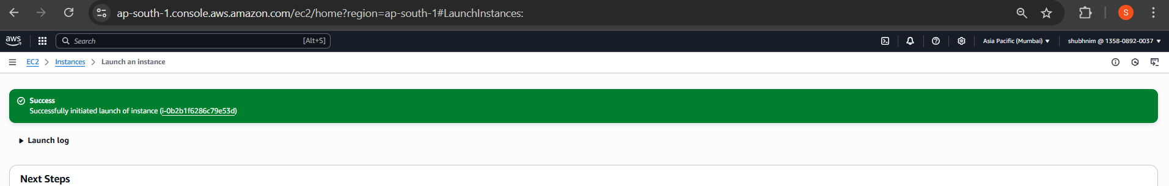

ADDED INBOUND RULE TO Allow Web Traffic:

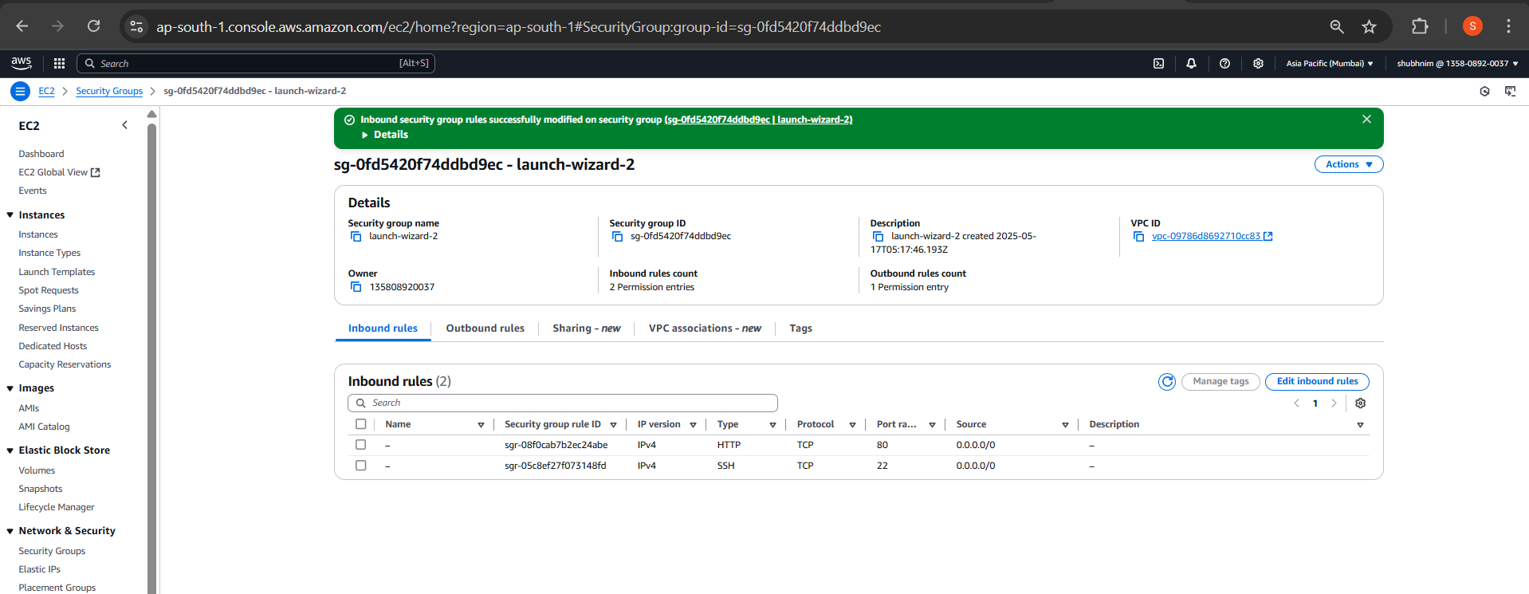

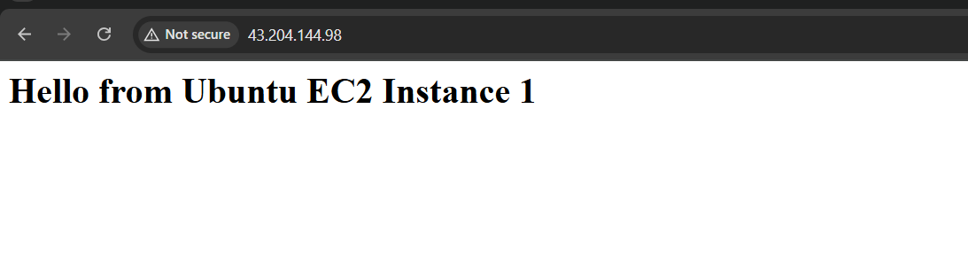

EC2-2:

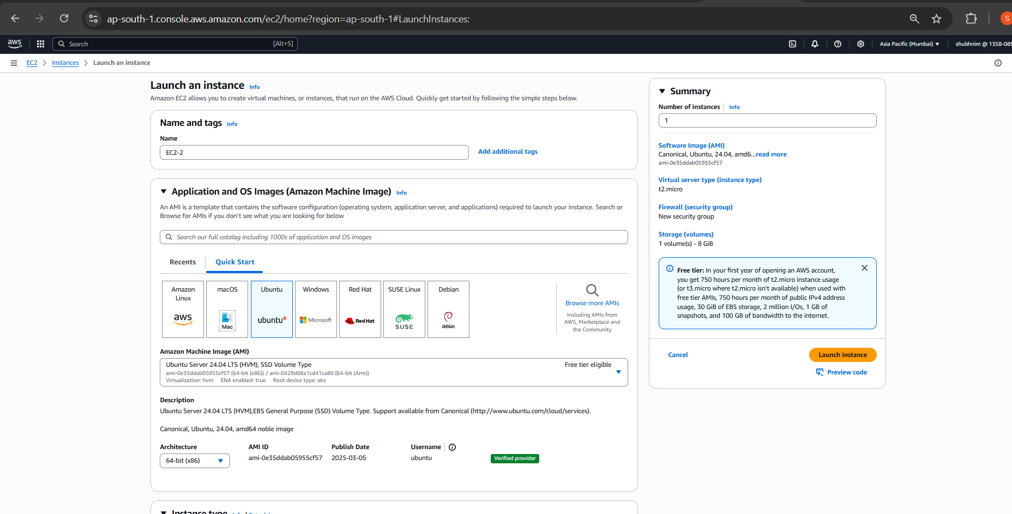

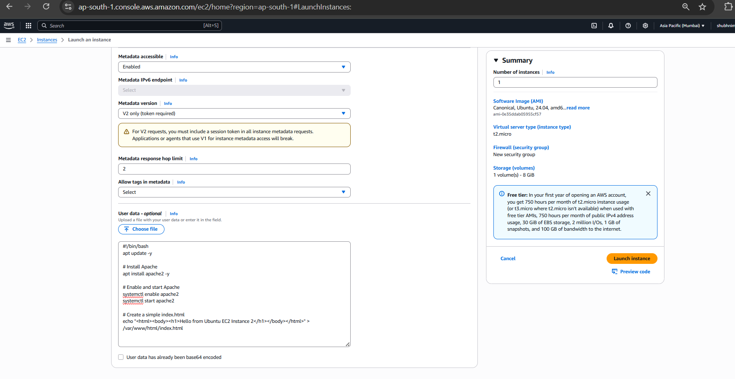

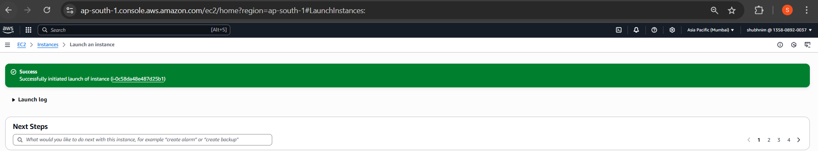

ADDED INBOUND RULE TO Allow Web Traffic

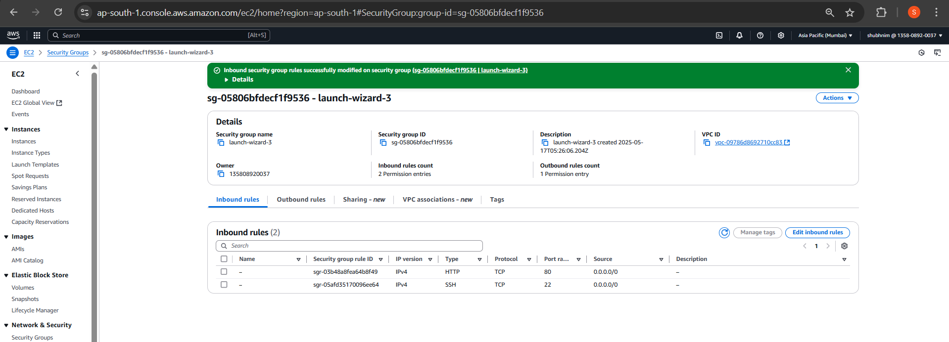

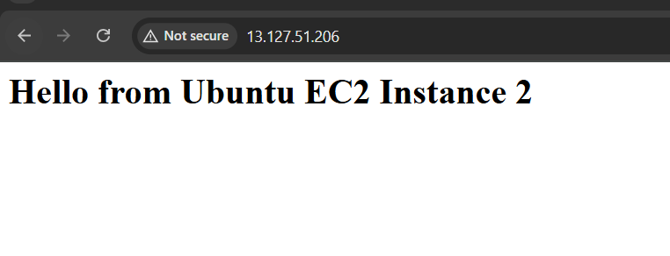

Create an Application Load Balancer:

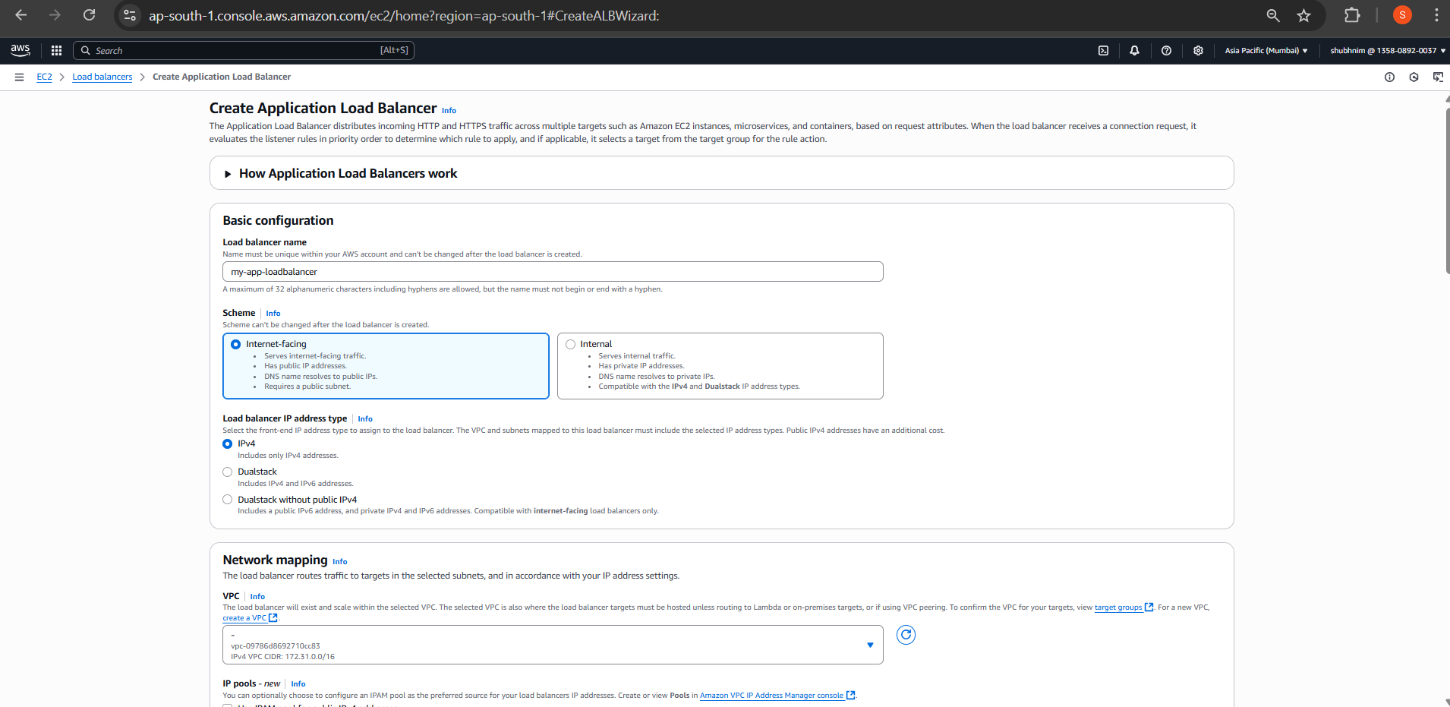

Configure Listeners

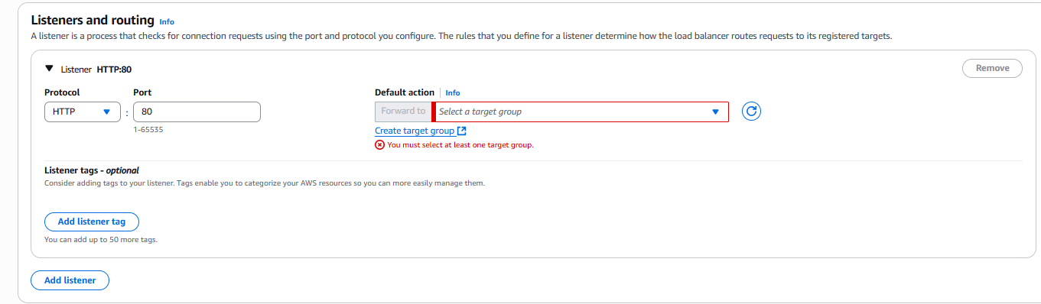

Create target group:

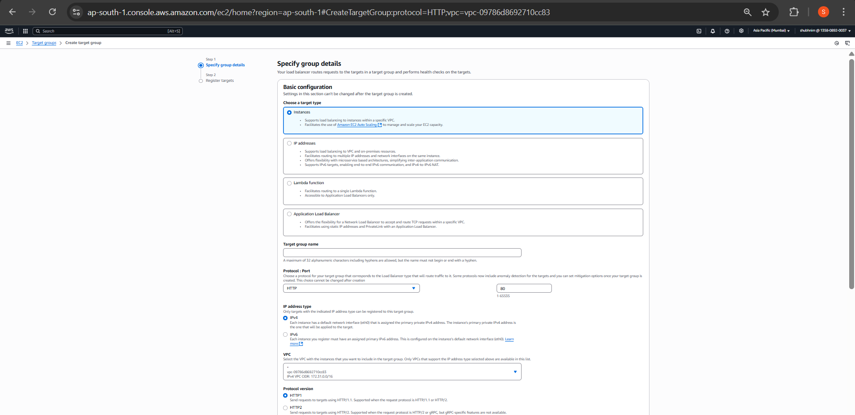

Register both instances:

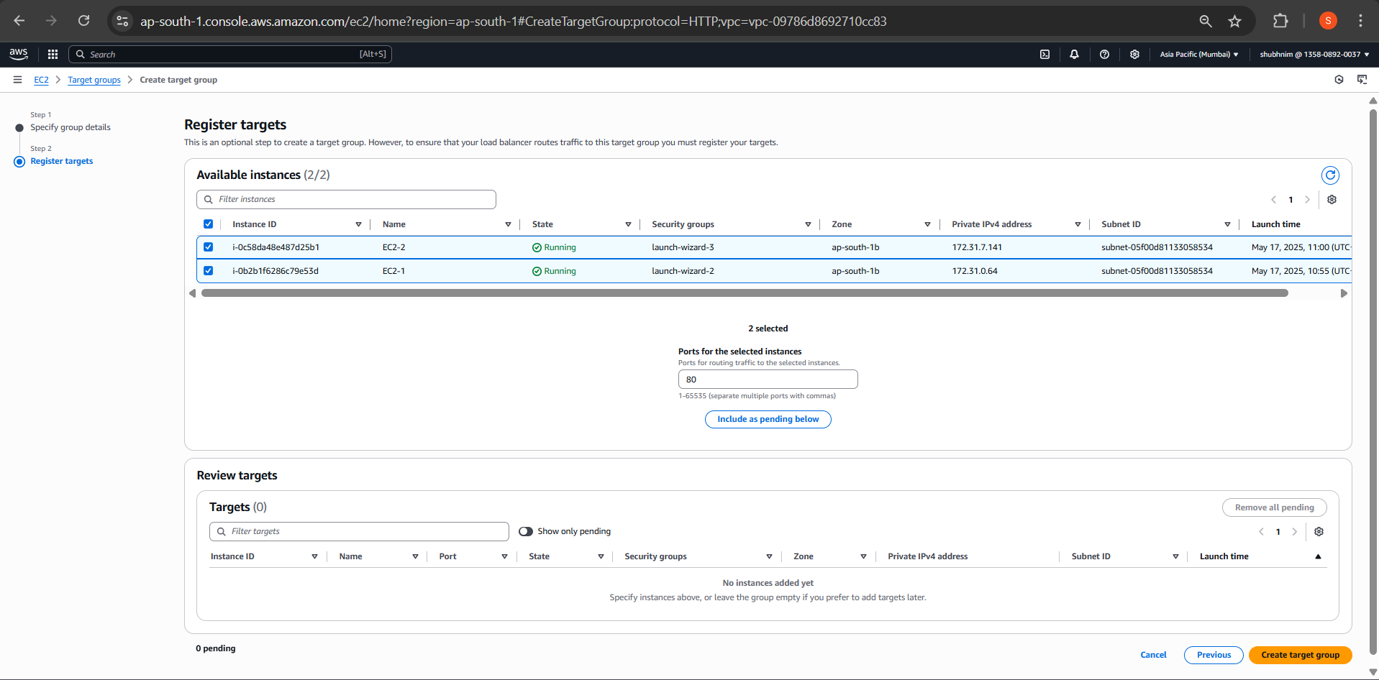

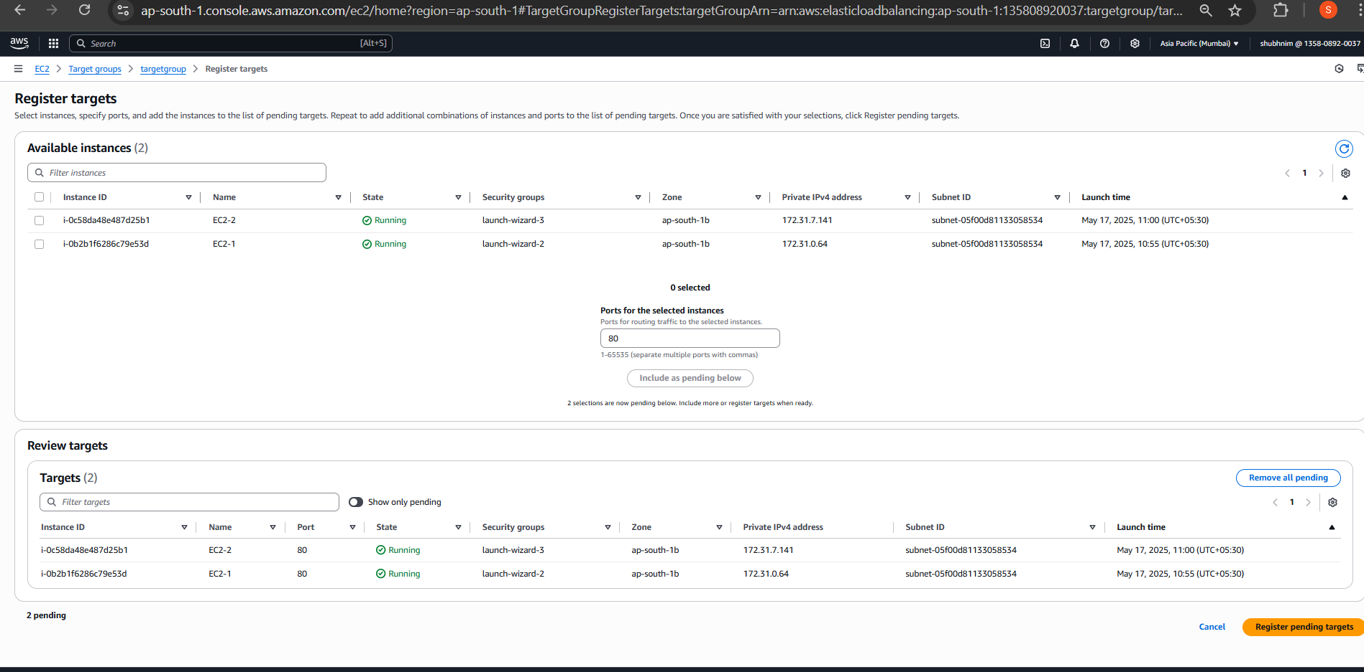

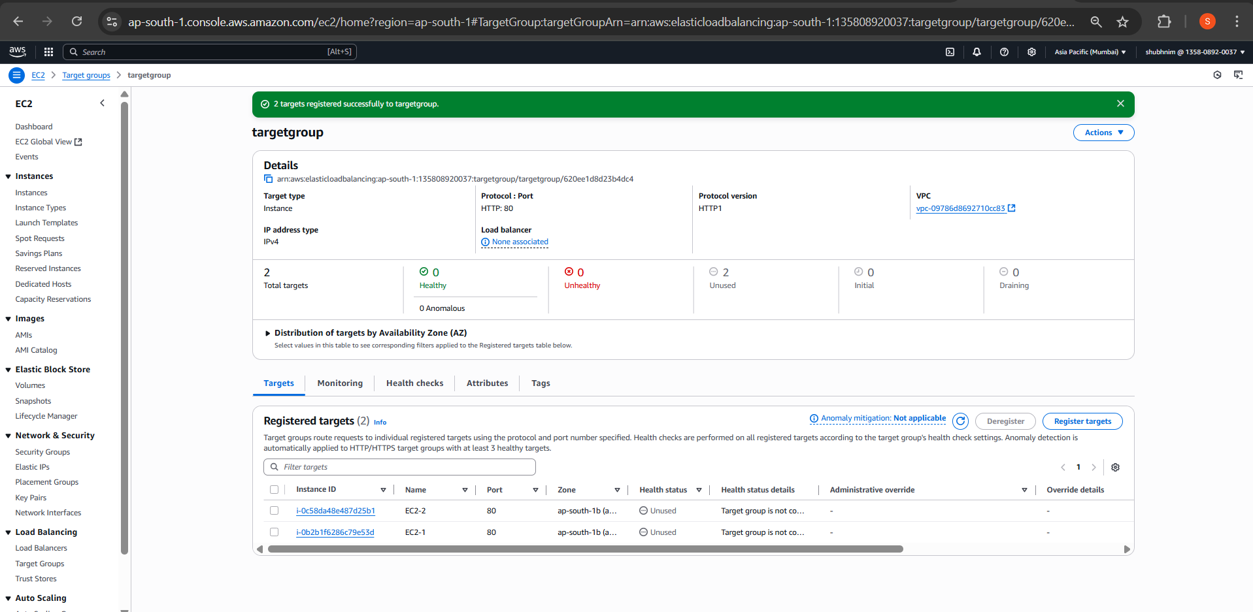

CREATING SUBNETS

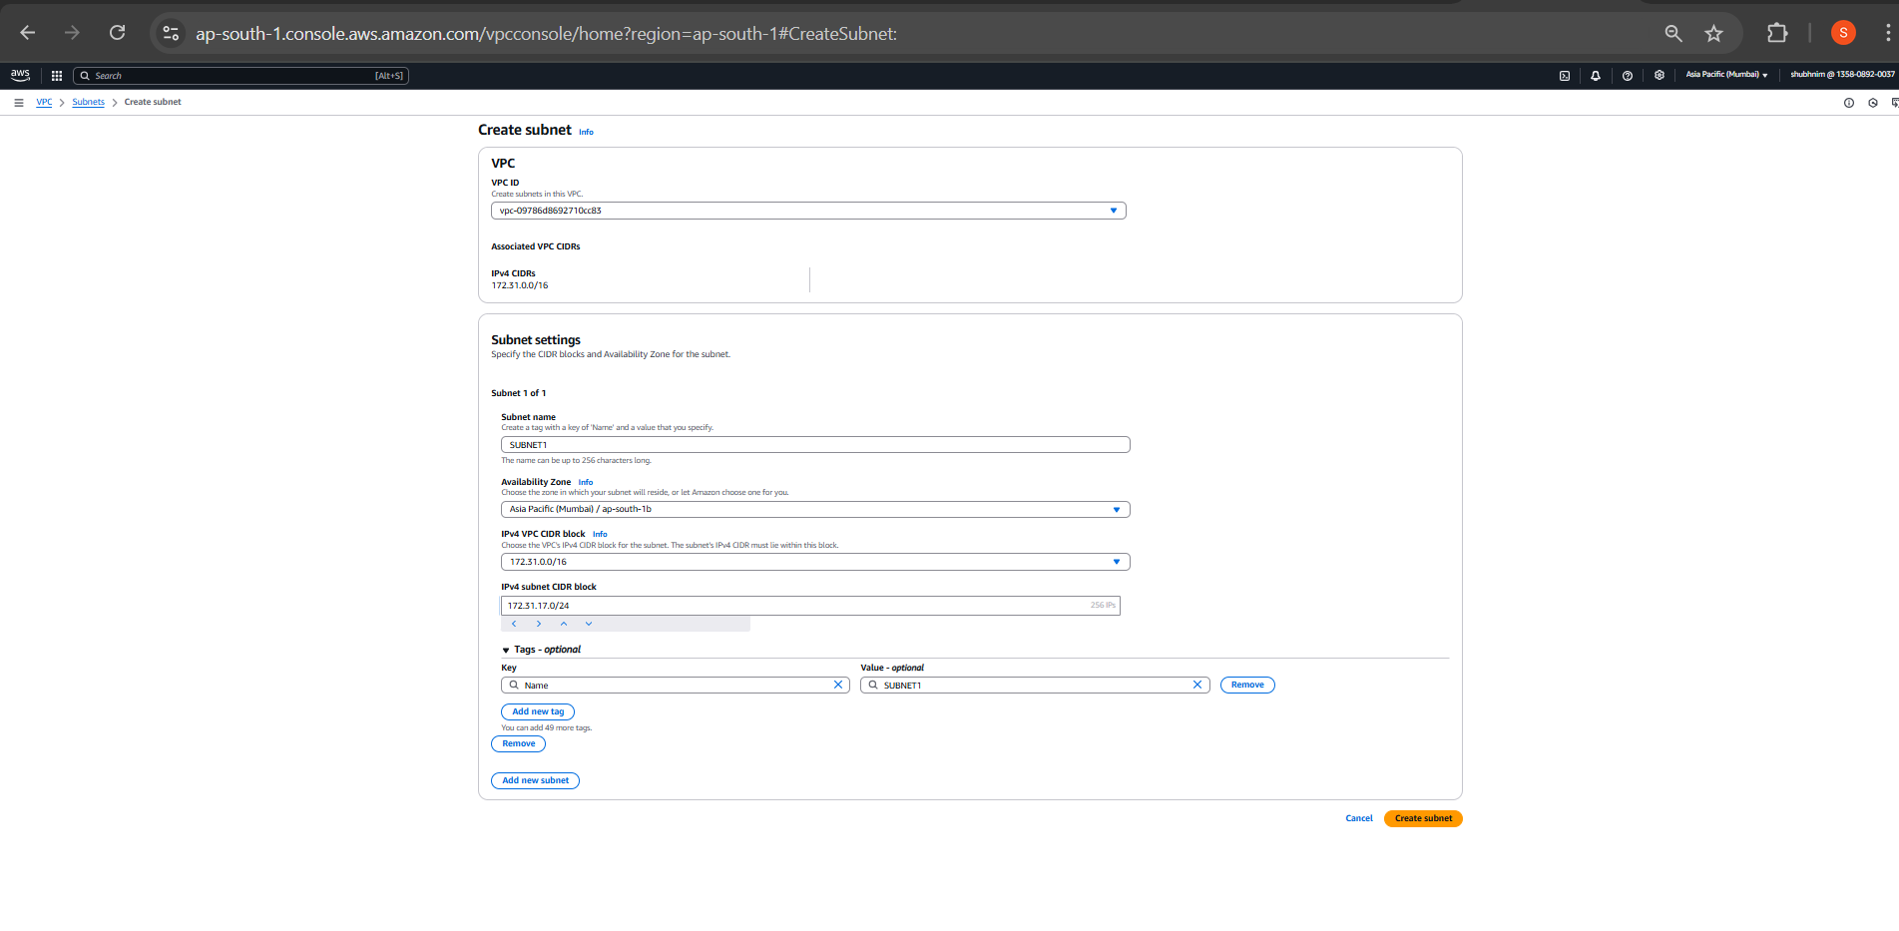

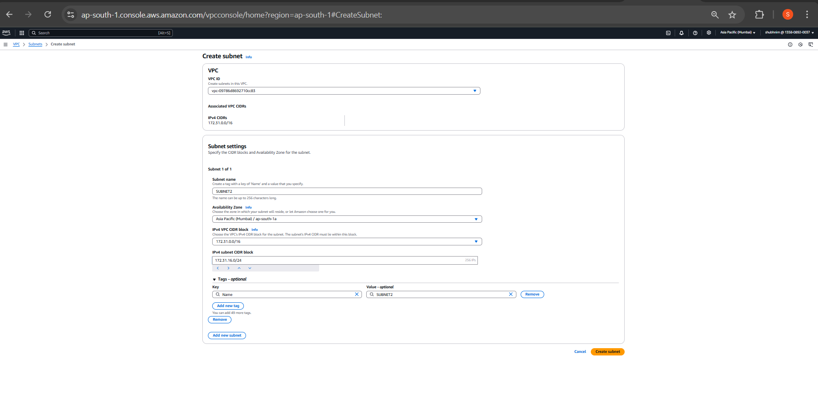

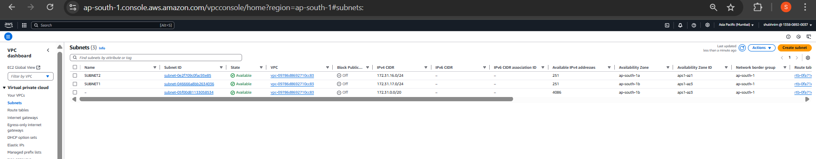

Load balancer:

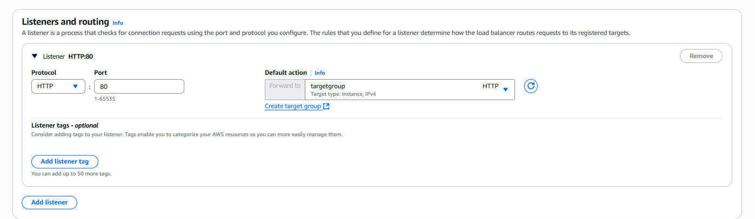

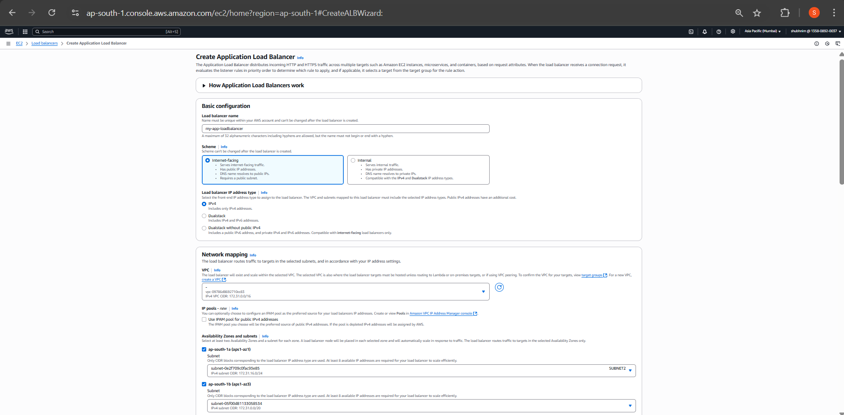

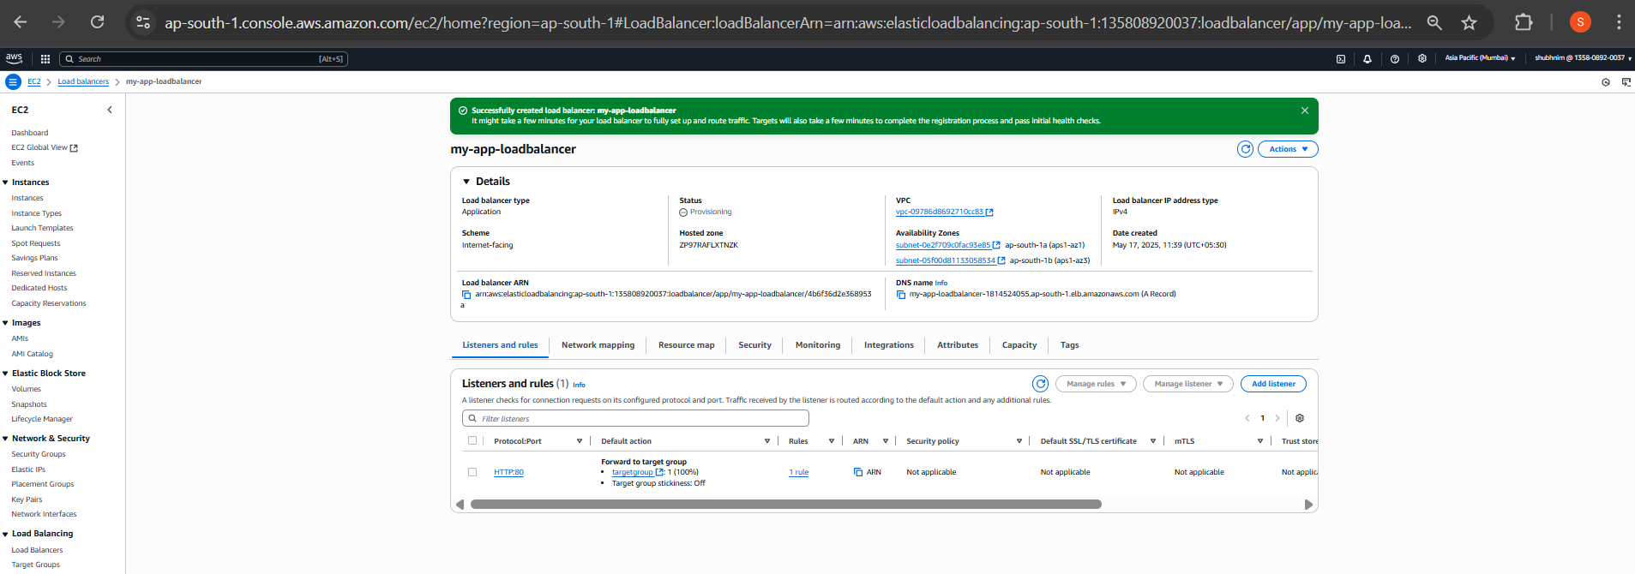

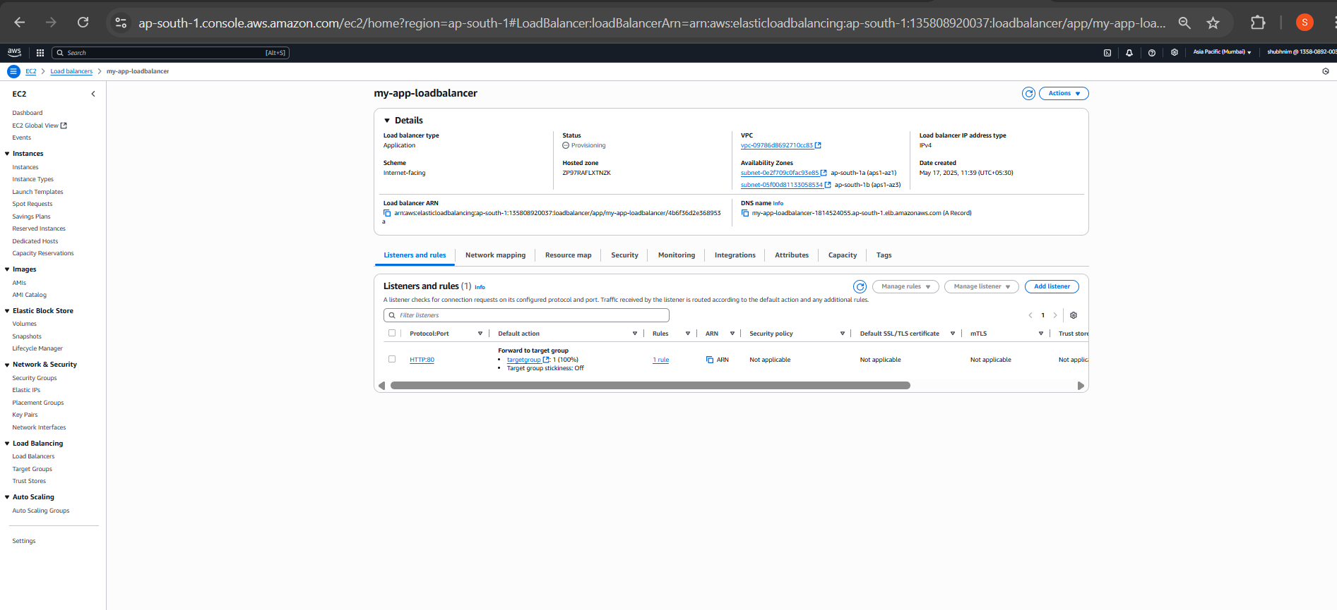

Security Groups for Load Balancer

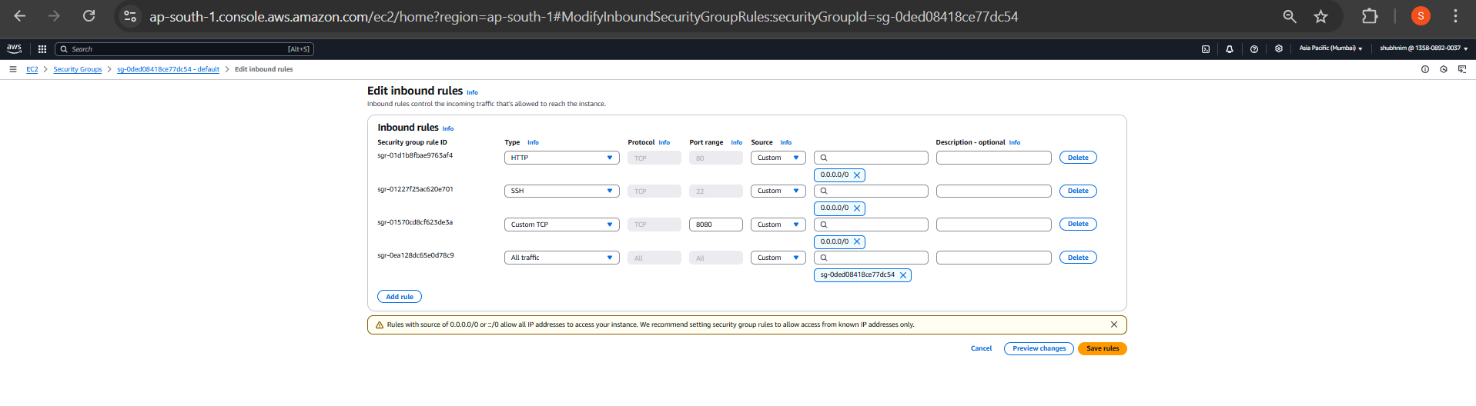

LOAD BALANCER DNS TESTING:

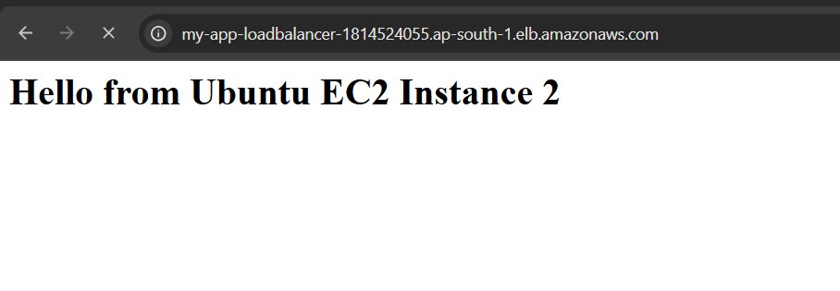

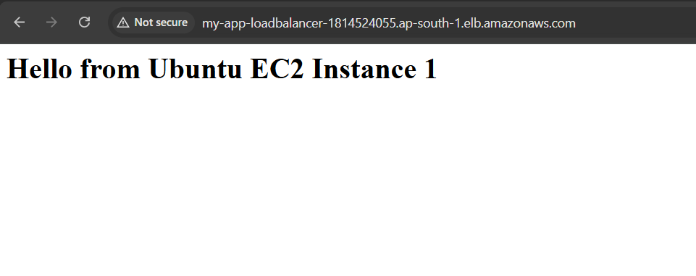

Ensure Traffic Origin is Load Balancer Only

**Modified EC2 Security Group**

Removed "0.0.0.0/0" from HTTP access

Add a new rule: HTTP from **Load Balancer Security Group -** [**sg-0ded08418ce77dc54**](https://ap-south-1.console.aws.amazon.com/ec2/home?region=ap-south-1#SecurityGroup:groupId=sg-0ded08418ce77dc54)

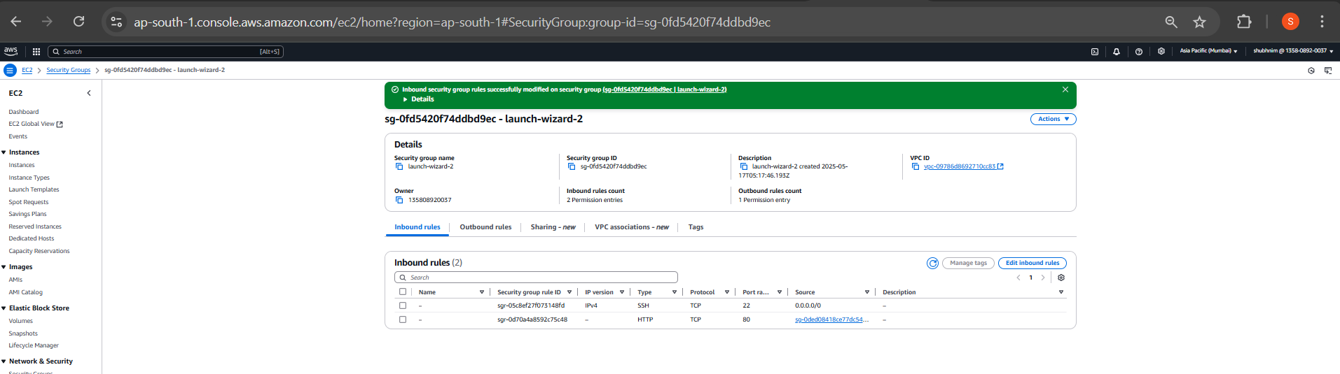

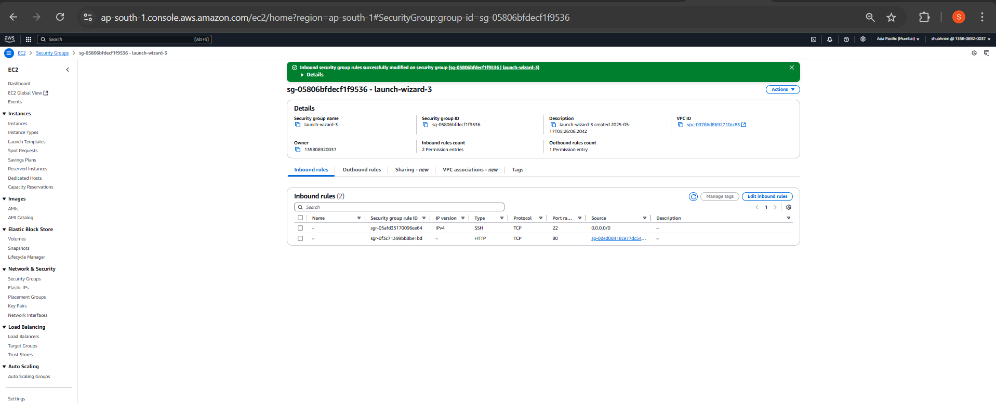

Noe trying to access the EC2’s **public IP** directly – its failing

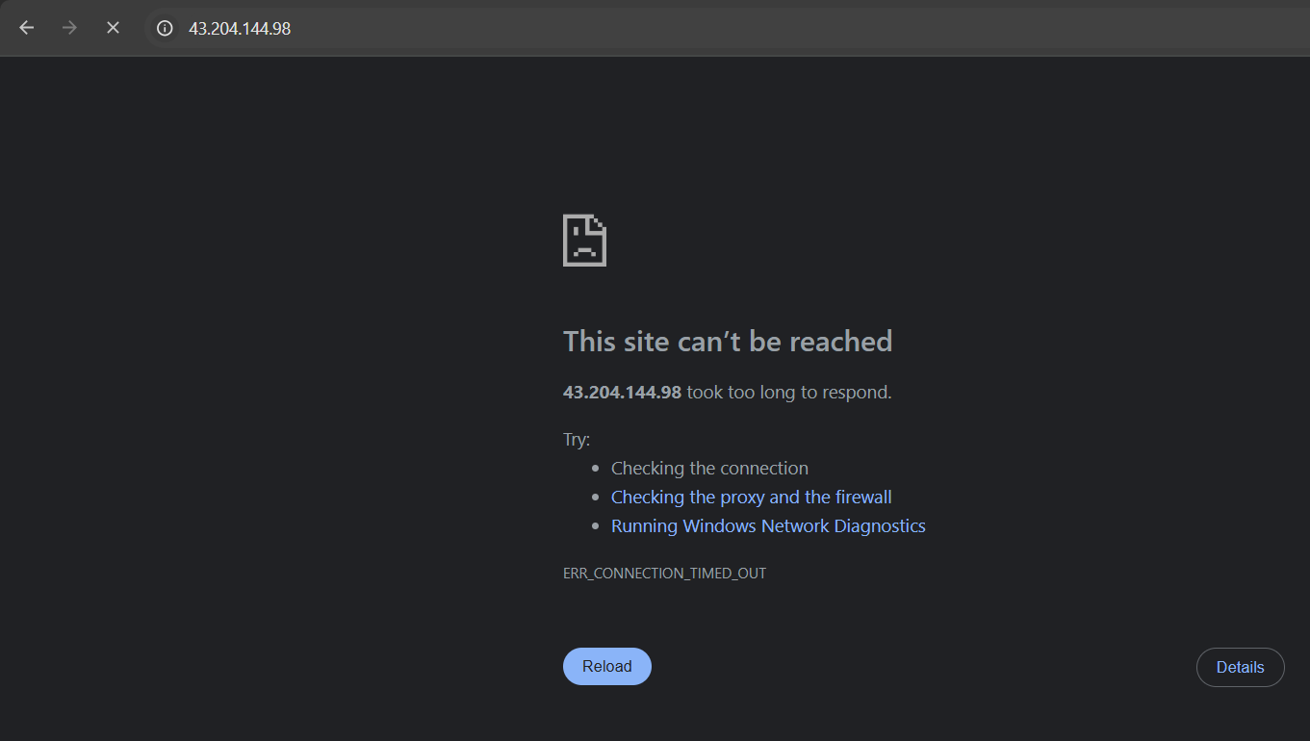

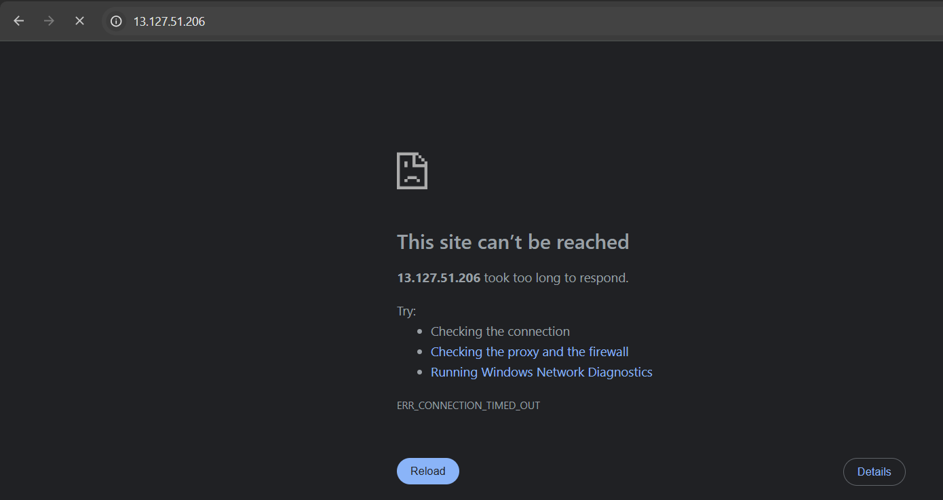

Tried accessing the **Load Balancer DNS – working fine**

